# Macintosh HD:Users:gcalderon:Dropbox:READY Model at KIPP:Logos and identifiers:KIPP Logo .png

# Get excited!

# Macintosh HD:Users:gcalderon:Dropbox:READY Model at KIPP:Photos/Pictures for Web:Pictures from Facebok:Inside the clinic:inside 6.png

# Through a partnership with Johns Hopkins, high quality pediatric care for your KIPPster is right down the hall! The Rales Health Center is located inside the school across from the cafeteria.

**Learn More About KIPP’s Rales Health Center:**

A doctor, a nurse practitioner, nurses, and a medical assistant are at the Rales Health Center every day. The doctor and nurse practitioner can provide well child care and emergency care if your child is sick or injured. The health center also offers care for children with health problems like asthma, allergies, ADHD or diabetes.

**Who can get care at the Rales Health Center?**

All KIPP students can see our nurses and medical assistant. In order to see the doctor or nurse practitioner, a student **must** be enrolled. You can enroll your KIPPster by signing a yellow consent form.

**What services can students get at the Rales Health Center?**

* School nurse visits:
  + Treatment for minor illnesses and injuries
  + Health education
  + Giving medications (with an order from a doctor or nurse practitioner)
  + Case management
  + Health screening (vision, hearing, blood pressure, weight)
* Doctor/nurse practitioner visits:
  + Regular check‐ups, sports physicals
  + Sick visits
  + Immunizations (shots)
  + Treatment of illness or injury (both minor and many emergencies)
  + Care and follow-up for chronic conditions like asthma, ADHD, allergies, and diabetes
  + Connections to health resources like getting health insurance or finding a specialist
  + Prescription medication delivery to school

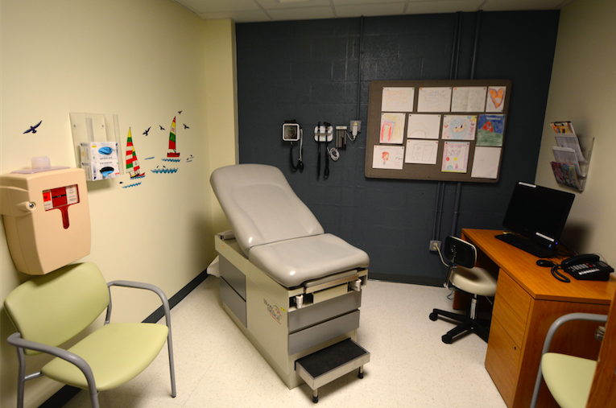Why would I take my child to the Rales Health Center? We use our doctor’s office or urgent care.

Having a health center in the school building is *convenient*. Most of the time, the Rales Health Center staff can treat your child and get them back to class quickly. You are welcome to come to visits with your child, but you don’t have to. You can stay at work or home and talk with them by phone. If your child is too sick to come to school but needs to see a doctor, you can bring them in. We may be able to see them faster than any urgent care facility.

My child already has a doctor, why should I enroll them at the Rales Health Center?

You do not have to give up your child’s doctor to enroll! The Rales Health Center staff work with your doctor. Many families sign up just in case their child needs to get urgent care at school or gets sick during the school day.

Does the Rales Health Center bill my insurance company?

Your insurance will be billed the same way it is at your child’s doctor’s office. The staff will always reach out to you to get your approval for a visit before billing your insurance. The Rales Health Center accepts all insurance types and sees students without insurance. They are committed to making sure that cost is not a barrier to care for your KIPPster.

**When is the Rales Health Center open?**

The health center is open M-F during regular school hours. You can schedule a visit, or your child can walk in anytime. Feel free to stop by or call us at 410-396-7844.

